**Apache Cordova/PhoneGap**

1. **Introduction**

Apache Cordova (formerly PhoneGap) is a popular mobile application development framework originally created by Nitobi. Adobe Systems purchased Nitobi in 2011, rebranded it as PhoneGap, and later released an open source version of the software called Apache Cordova. (Adobe Announces Agreement to Acquire Nitobi, Creator of PhoneGap, 2016)

Apache Cordova enables software programmers to **build applications for mobile devices using CSS3, HTML5, and JavaScript** instead of relying on platform-specific APIs like those in Android, iOS, or Windows Phone. It enables **wrapping up** of CSS, HTML, and JavaScript code **depending upon the platform of the device**. It extends the features of HTML and JavaScript to work with the device.

The resulting applications are **hybrid**, meaning that they are neither truly native mobile application (because all layout rendering is done via Web views instead of the platform's native UI framework) nor purely Web-based (because they are not just Web apps, but are packaged as apps for distribution and have access to native device APIs).

Website of Apache Cordova: <https://cordova.apache.org/>

1. **Design and rationale**

The core of Apache Cordova applications uses CSS3 and HTML5 for their rendering and JavaScript for their logic. **HTML5 provides access to underlying hardware such as the accelerometer, camera, and GPS.** However, browsers' support for HTML5-based device access is not consistent across mobile browsers, particularly older versions of Android. To overcome these limitations, Apache Cordova embeds the HTML5 code inside a native Web View on the device, **using a foreign function interface to access the native resources of it.**

Apache Cordova **can be extended with native plug-ins**, allowing developers to add **more functionalities** that can be called from JavaScript, making it communicate directly between the native layer and the HTML5 page. These plugins allow access to the device's accelerometer, camera, compass, file system, microphone, and more.

However, the use of Web-based technologies leads some Apache Cordova applications to run **slower** than native applications with similar functionality. (Diwakar, 2012)Adobe Systems warns that applications may be rejected by Apple for being too slow or not feeling "native" enough (having appearance and functionality consistent with what users have come to expect on the platform). This can be an issue for some Apache Cordova applications.

1. **Supported platforms**

Apache Cordova currently supports development for the operating systems Apple iOS, Bada, BlackBerry, Firefox OS, Google Android, LG WebOS, Microsoft Windows Phone (7 and 8), Nokia Symbian OS, Tizen (SDK 2.x), and Ubuntu Touch. The table below is a list of supported features for each operating system. (Platform Support, 2016)

|  |  |  |  |  |  |  |  |  |  |  |  |  |
| --- | --- | --- | --- | --- | --- | --- | --- | --- | --- | --- | --- | --- |
| **Feature** | [**Android**](https://en.wikipedia.org/wiki/Android_(operating_system))[[34]](https://en.wikipedia.org/wiki/Apache_Cordova#cite_note-34) | [**Apple iPhone /iPhone 3G**](https://en.wikipedia.org/wiki/Apple_iOS) | [**Apple iPhone 3GS and newer**](https://en.wikipedia.org/wiki/Apple_iOS) | [**Bada**](https://en.wikipedia.org/wiki/Bada) | [**BlackBerry 10 and PlayBook OS**](https://en.wikipedia.org/wiki/BlackBerry_10) | [**BlackBerry OS 5.0-6.0+**](https://en.wikipedia.org/wiki/BlackBerry_OS) | [**Firefox OS**](https://en.wikipedia.org/wiki/Firefox_OS) | [**Symbian**](https://en.wikipedia.org/wiki/Symbian) | [**Tizen**](https://en.wikipedia.org/wiki/Tizen) | [**webOS**](https://en.wikipedia.org/wiki/WebOS) | [**Ubuntu Touch**](https://en.wikipedia.org/wiki/Ubuntu_Touch) | [**Windows Phone**](https://en.wikipedia.org/wiki/Windows_Phone) |
| [Accelerometer](https://en.wikipedia.org/wiki/Accelerometer) | Yes | Yes | Yes | Yes | Yes | Yes | Yes | Yes | Yes | Yes | Yes | Yes |
| [Camera](https://en.wikipedia.org/wiki/Camera) | Yes | Yes | Yes | Yes | Yes | Yes | Yes | Yes | Yes | Yes | Yes | Yes |
| [Compass](https://en.wikipedia.org/wiki/Compass) | Yes | N/A | Yes | Yes | Yes | N/A | Yes | N/A | Yes | Yes | Yes | Yes |
| [Contacts](https://en.wikipedia.org/wiki/Contact_list) | Yes | Yes | Yes | Yes | Yes | Yes | Yes | Yes | Yes | N/A | N/A | Yes |
| File | Yes | Yes | Yes | N/A | Yes | Yes | N/A | N/A | Yes | N/A | Yes | Yes |
| [Geolocation](https://en.wikipedia.org/wiki/Geolocation) | Yes | Yes | Yes | Yes | Yes | Yes | Yes | Yes | Yes | Yes | Yes | Yes |
| Media | Yes | Yes | Yes | N/A | Yes | N/A | N/A | N/A | Yes | N/A | Yes | Yes |
| Network | Yes | Yes | Yes | Yes | Yes | Yes | Yes | Yes | Yes | Yes | Yes | Yes |
| Notification (alert, sound, vibration) | Yes | Yes | Yes | Yes | Yes | Yes | Yes | Yes | Yes | Yes | Yes | Yes |
| Storage | Yes | Yes | Yes | N/A | Yes | Yes | Yes | Yes | Yes | Yes | Yes | Yes |

1. **Architecture**

There are several components to a Cordova application. The following diagram shows a high-level view of the Cordova application architecture.

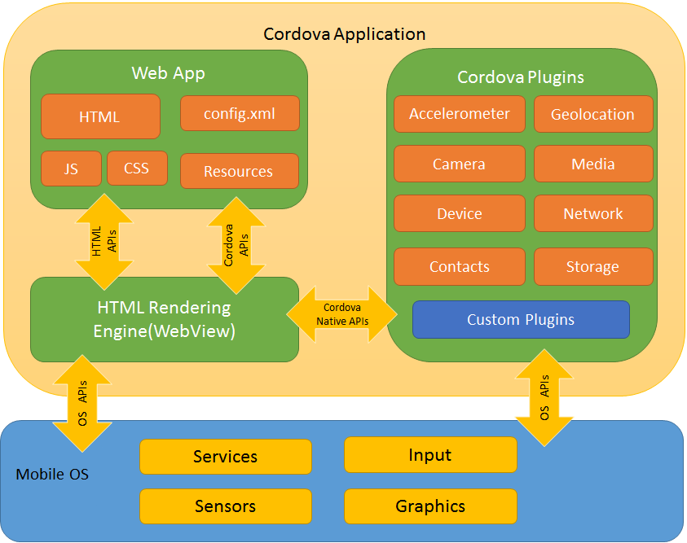

Figure Cordova App Architecture (Documentaion: introduction, 2016)

1. **Interesting website about using PhoneGap for Hybrid application:**

https://www.sitepoint.com/using-phonegap-for-hybrid-app-development/

“I chose PhoneGap because it supports many development platforms: iOS, Android, BlackBerry, Windows, Symbian, and even Tizen.”

“Another reason for choosing PhoneGap was that it is a native WebView component with HTML5-CSS3 application and it has a structured API that uses JavaScript to access native functionalities of mobile devices. This means that an app you build on PhoneGap can access native functions from the devices as well as the mobile operating system. Theoretically, you can build high-performance apps on PhoneGap and make them work on several mobile platforms”

“PhoneGap apps use HTML5 and CSS3 for rendering, while JavaScript is used for logic.”

1. **Difference between Cordova, PhoneGap and Ionic**

Cordova also referred as Apache Cordova, is open source JavaScript framework which helps you to build mobile apps with capability to access the device hardware. However, you need HTML5, CSS3, JavaScript, JQueryMobile, Sencha to build the UI. Cordova cannot be used to build UI of a mobile app. It complements other web technologies which are used to build mobile apps.

PhoneGap is propitiatory version of Cordova maintained by Adobe. It just provides some more extra add-ons on top of existing Cordova. App built on PhoneGap can access native functions from the devices as well as the mobile operating system by using JavaScript.

Ionic is combination of AngularJS and Cordova. Ionic is a complete open-source SDK for hybrid mobile app development. You can think of it as a full stack framework for building cross-platform mobile apps. Ionic provides all the functionality that can be found in native mobile development SDKs. Users can build their apps, customize them for Android or iOS, and deploy through Cordova.

<https://www.quora.com/What-is-the-difference-between-PhoneGap-Cordova-and-Ionic>

<https://en.wikipedia.org/wiki/Ionic_(mobile_app_framework)>

# Bibliography

*Adobe Announces Agreement to Acquire Nitobi, Creator of PhoneGap*. (2016, 10 31). Retrieved from Adobe: http://www.adobe.com/aboutadobe/pressroom/pressreleases/201110/AdobeAcquiresNitobi.html

Diwakar, S. (2012, 6 21). *Titanium vs Phonegap vs Native application development.* Retrieved from Sapandiwakar: http://www.sapandiwakar.in/api-research-study-iphone-and-android-applications/

*Documentaion: introduction*. (2016, 10 31). Retrieved from Cordova: https://cordova.apache.org/docs/en/latest/guide/overview/index.html

*Platform Support*. (2016, 10 31). Retrieved from Adobe PhoneGap: http://docs.phonegap.com/en/edge/guide_support_index.md.html#Platform%20Support